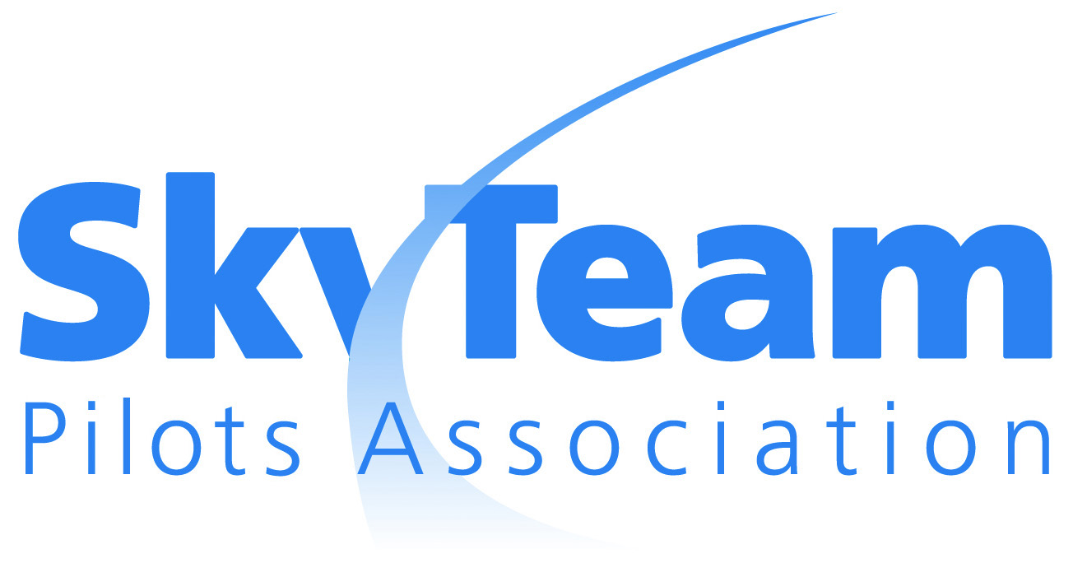

Rome, Italy

4-5 March 2013
AGENDA

Day 1: March 4
0800-0900 Breakfast
0900-0910 Welcome/Call to order/Administrative Items
0910-0915 Chairman’s remarks
0915-0920 Host remarks
0920-0930 New entrants and observers
0930-0940 Meeting Minutes approval/Meeting Agenda
Review
0940-1000 SCPA update
1000-1030 SSQFE/ SPA Safety Committee update
1030-1100 Aerolíneas Argentinas pilot union APLA presentation/introduction
1100-1130 coffee break
1130-1200 Preparation for Michael Wisbrun
1200-1330 lunch
1330-1500 Presentation Mr Michael Wisbrun CEO SkyTeam
1500-1530 Coffee break
1530-1630 Kye Johanning ALPA E&FA Global aviation trends SkyTeam update
1630-1700 Press release

Day 2: March 5

0800-0900 Breakfast
0900-1030 Captain Paul van den Berk SSQFE Chairman
1030-1100 coffee break
1100-1200 Capt Roberto Germano Alitalia Flight Oper. Post Holder
1200-1230 Capt Mike Pinho on Global Pilots Symposium and Capt Chris Lynch EVP-NAM
1230-1400 lunch
1400-1430 New SkyTeam Alliance entrants
1430-1500 Current subjects/issues
1500-1530 SPA Safety committee
1530-1600 Coffee break
1600-1630 Next meeting venue
1630-1650 Press release
1650-1700 Closing remarks
1700 Adjourn
Reminders
Bring your Safety delegates to this meeting for the SPA Safety Committee meeting. The SPA Safety meeting starts 1 day earlier on Sunday 3 March.

At least 15 days prior to the meeting, each Member Union must confirm to the SPA Chairman and other Member Unions its intention to attend and identify its attendees

Place your meeting union updates in the SPA Dropbox prior to the SPA meeting. If you would like to do a presentation, please let us know in advance and limit it to 10 min.
Please remember that if the Executive Board (EB) member to your delegation is not attending in person, you must provide a letter authorizing one of your delegates to have full authority of the EB member

